Name:

Self-Reflection

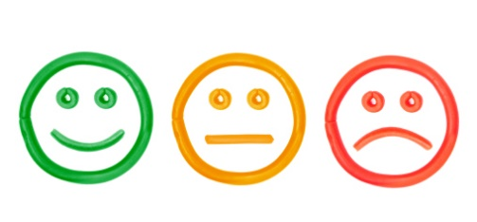
- I helped my friends.

- I used friend words.

- I made good choices.

- I did not tattle.

- I followed the
classroom rules.

