Name:

Grade 2 Self-Reflection

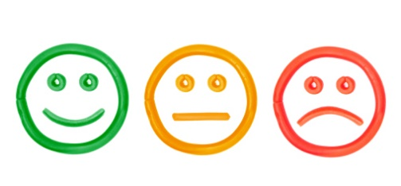
- I can copy a pattern.

- I can extend a pattern.

- I can fix a pattern.

- I can make a repeating
pattern.
- I can make an increasing
pattern.

