Name:

Grade 1 Self-Reflection

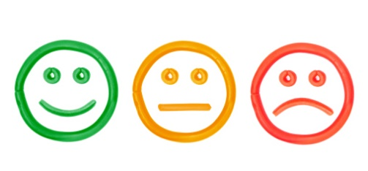
- My family is different
than other families.

- My family is the same
as other families.

- I know how many
people are in my family.

- I help at home.

- I did my best work.

